Asia-China-Coin-Knife Money-H4.7,4.5, 4.5, 4.4, 4.7, 4.3

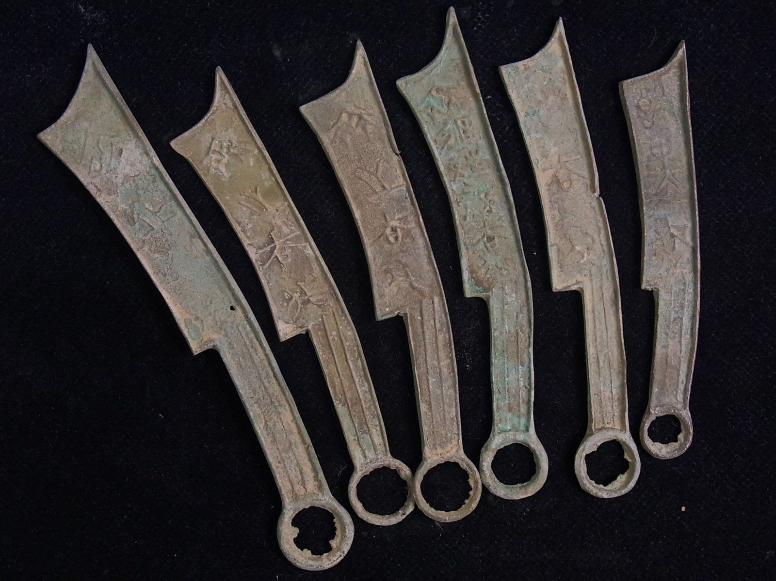

SHAPE \\* MERGEFORMAT 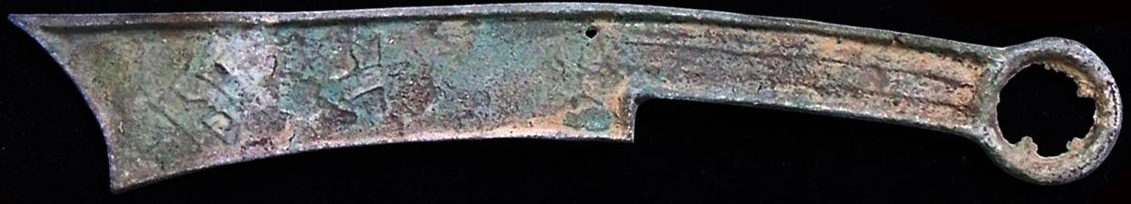 INCLUDEPICTURE "../../../Local%20Settings/Temp/scl13.jpg" \\* MERGEFORMATINET SHAPE \\* MERGEFORMAT 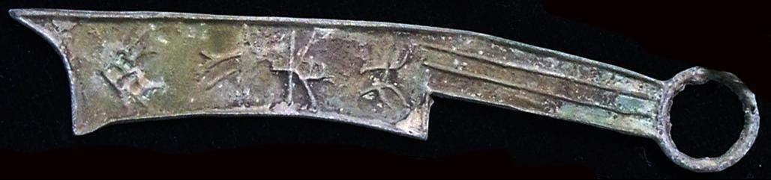 SHAPE \\* MERGEFORMAT 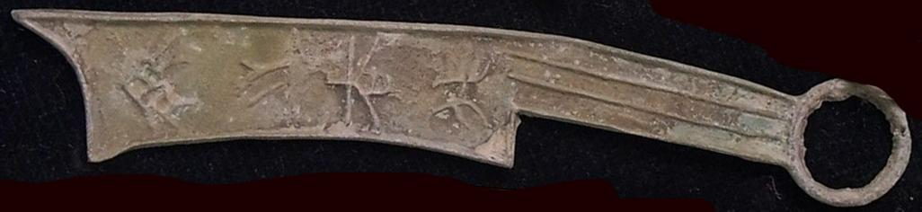 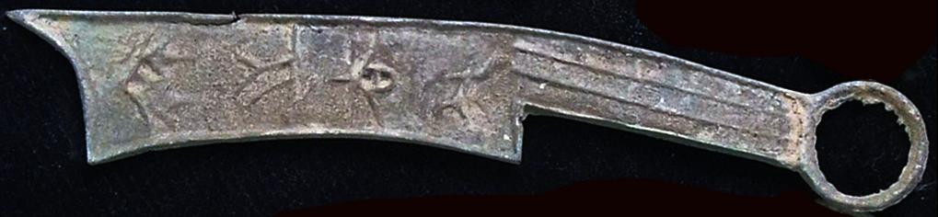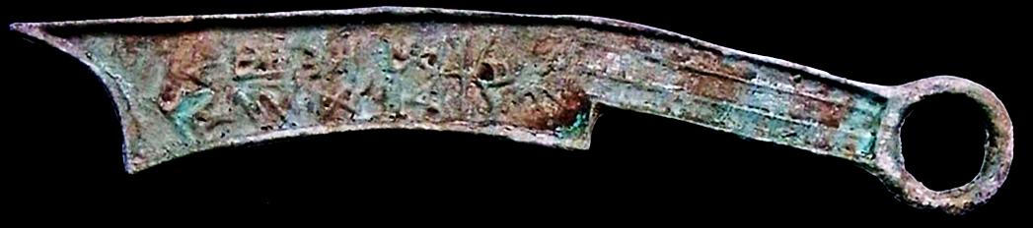 INCLUDEPICTURE "../../../Local%20Settings/Temp/scl12.jpg" \\* MERGEFORMATINET SHAPE \\* MERGEFORMAT 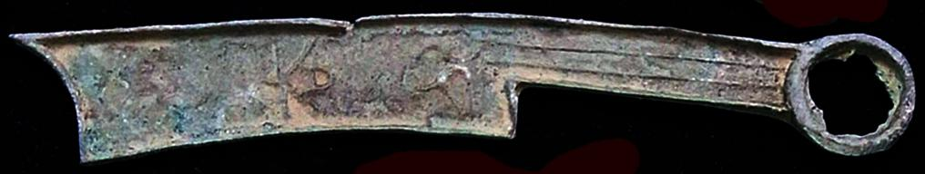 SHAPE \\* MERGEFORMAT 